Allflex RS420 Stick Reader
&
Tag Manager Download
&
Basic Reader Setup

Also
Updating reader firmware

Tag Manager Software

Support - Allflex Livestock Intelligence Australia
Please click on the above link to take you to the tag manager download page, then select Software Downloads in the menu, then Tag Manger, the middle option on the page. This should automatically start the download to your PC.
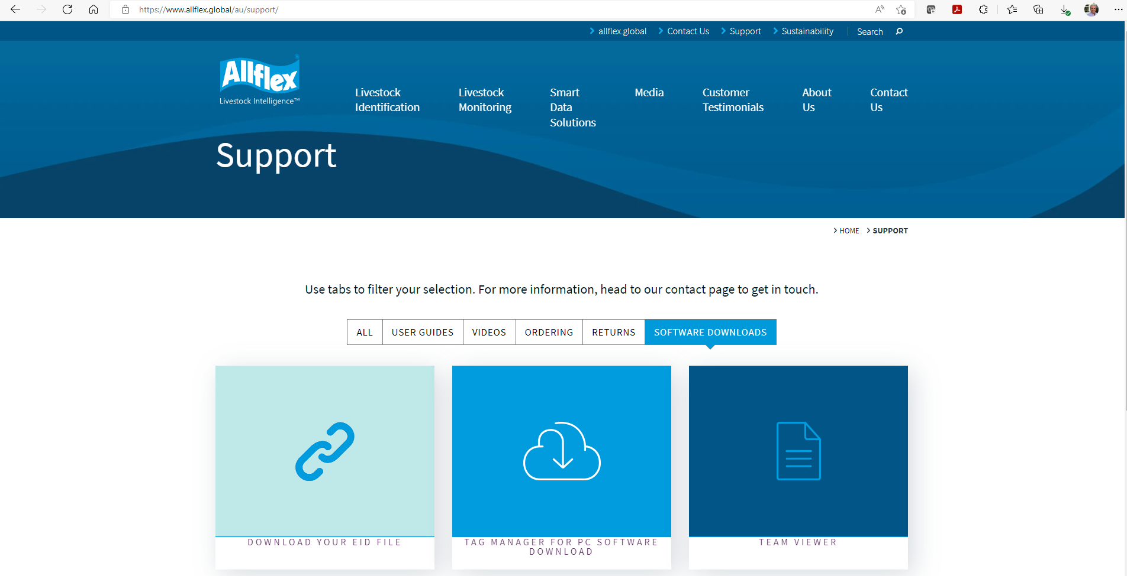
Please open the download file and select extract all then run to save the Tag Manager software to your PC.

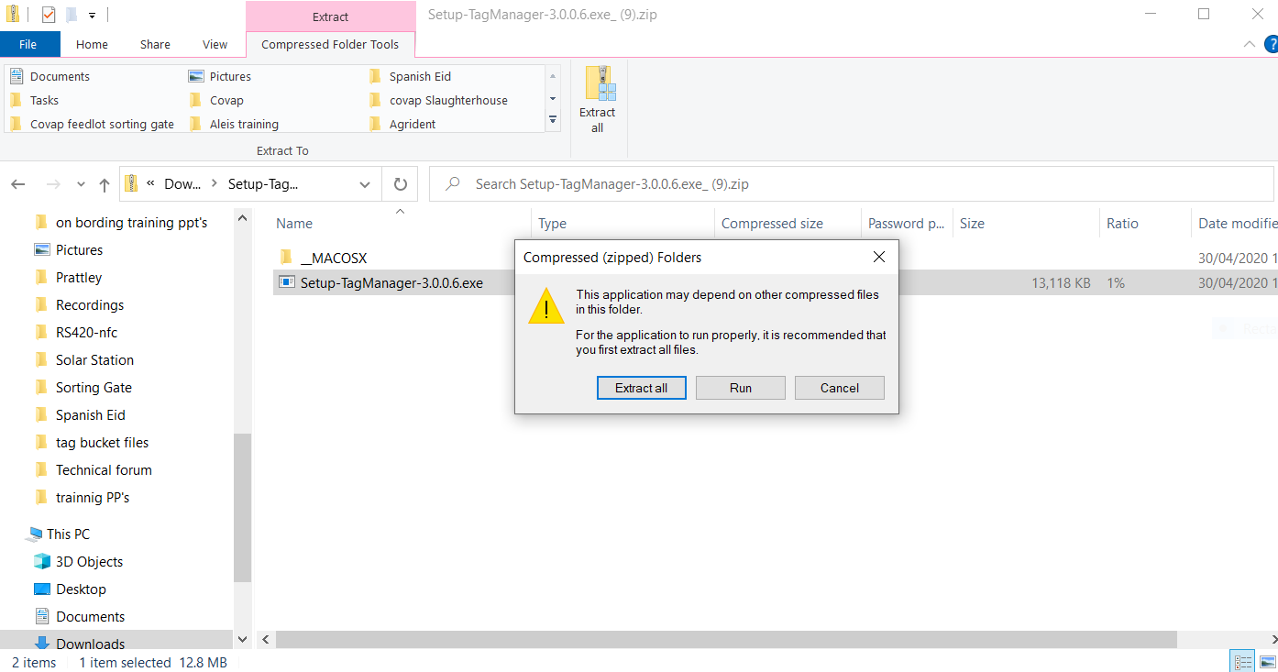

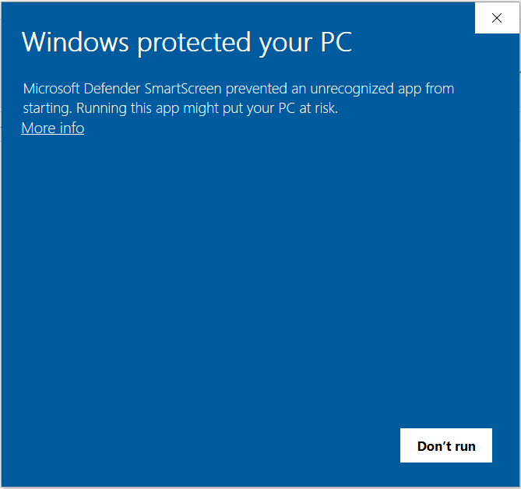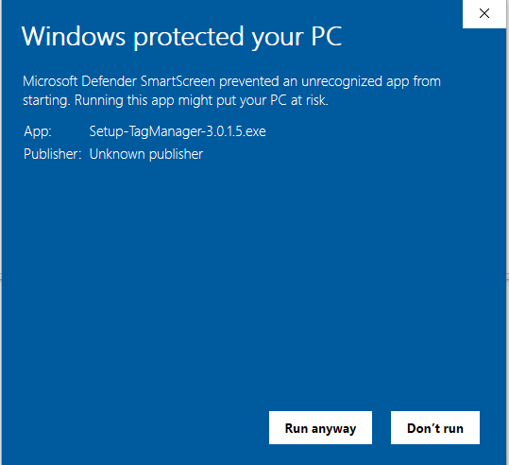
If windows block the download, please select More info and then select run anyway on the next screen.

Follow the install wizard to complete the software setup and install, then connect the reader to the PC using the curly data cable (it may take a short while to download the drivers!), Open the Tag Manager Software, if you get a notification to say there is a newer version, please update the software. The software should locate the reader port and connect as below. If you don’t see the column down the left-hand side, then click go to advanced, this box should be in the top left of the screen, the image below as it is already in advanced has go to basic in it.

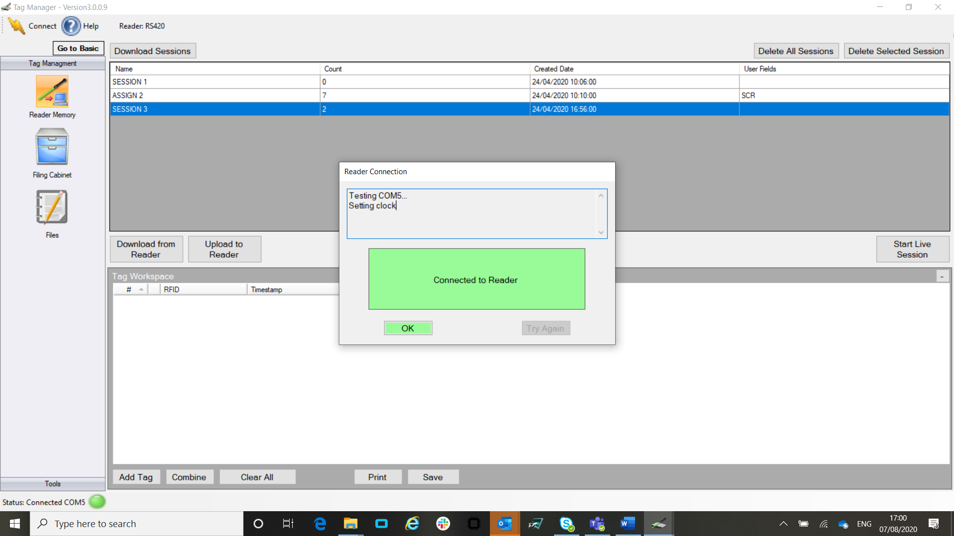

Click on the tools option on the bottom of the left-hand column.

You should now see the below image, in the left-hand column, select the predefined settings option.
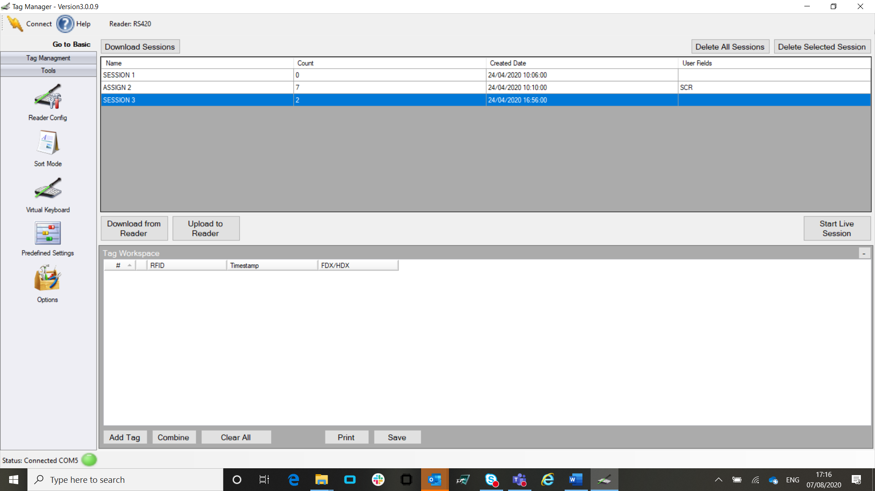

Highlight the 16 digits in ID code formats and apply, then highlight the TruTest 16 digit and apply, you may see the programme tell you that several values have changed which is great.
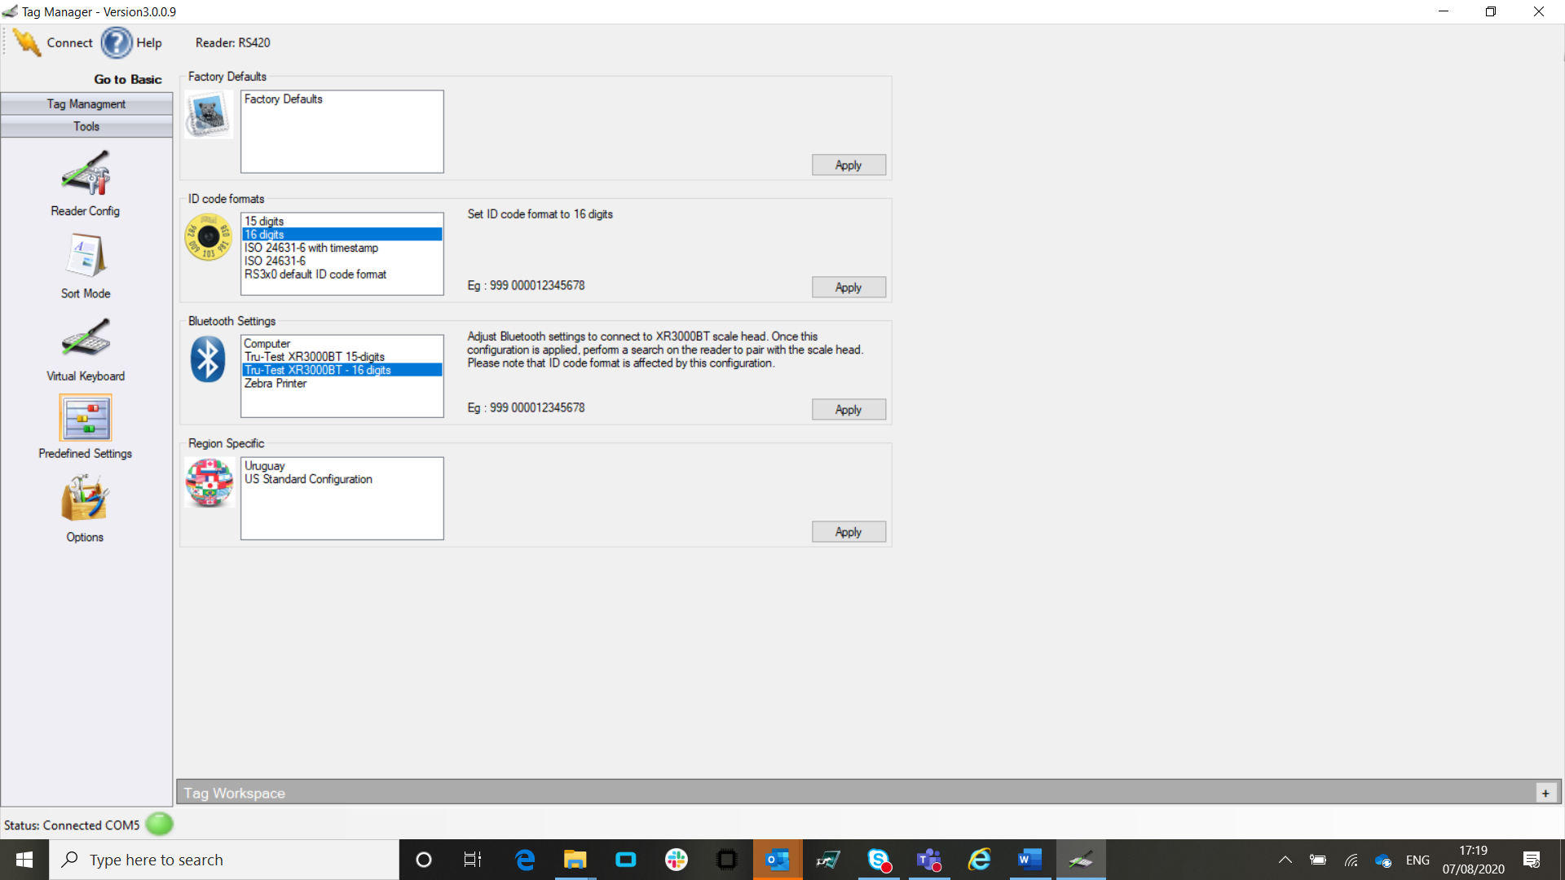

Basic Reader Setting

If your reader date and time is not correct, you can follow these steps to correct it, although it should set date and time on initial connection!
Select the reader config option at the top of the left-hand column, then select the reader clock along the top bar, you can either manual adjust this or get the PC time and date and apply.
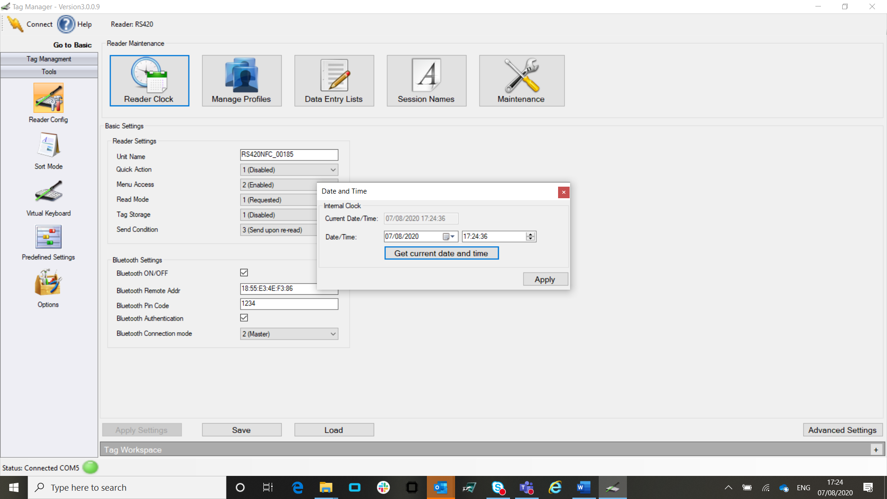

There are lots of other things you can do from within this software like firmware updates etc, it may be well worth doing this too.
Select the maintenance tab along the top bar and then choose the firmware update and follow the instructions. HOWEVER, I WOULD ONLY DO THIS WHEN YOU HAVE NO IMPORTANT INFO ON THE READER. Also make sure that the reader does not lose its connection while it is updating!!!

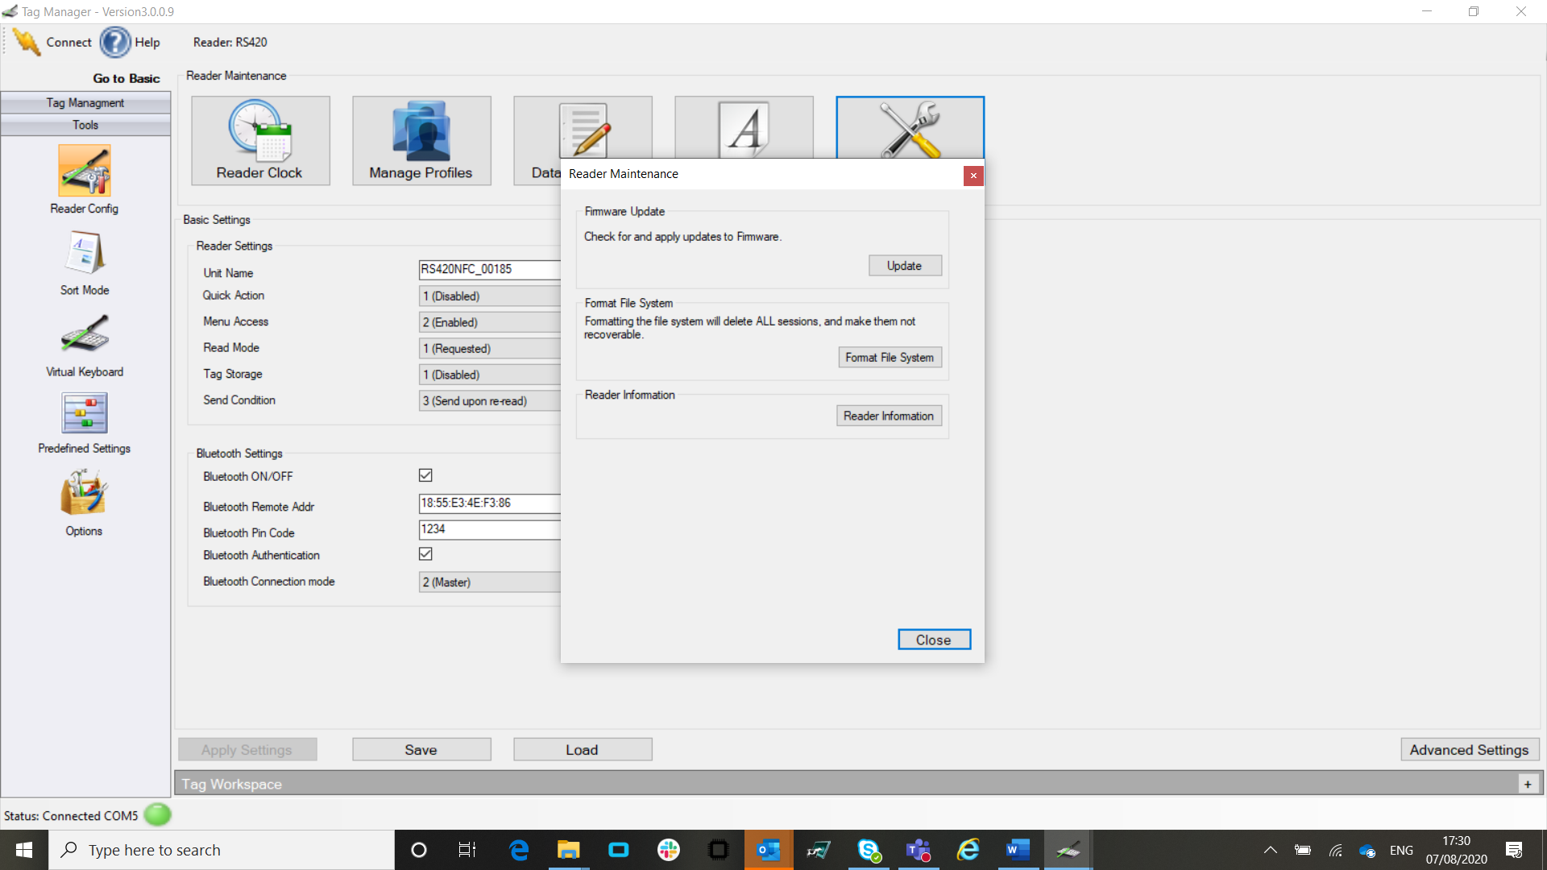

The above should have set your reader in the best format for standard use.

WHAT THE READER DISPLAYS

To set how the reader displays tags, you will need to select advanced settings in the bottom right of the screen, you will get a waring but just continue. Go to the last option in the menu, Tag Processing, then set as below if you want the large digits to be the last 6 digits from the data field (normally a management or official number uploaded as a Tag Bucket file) and apply settings.

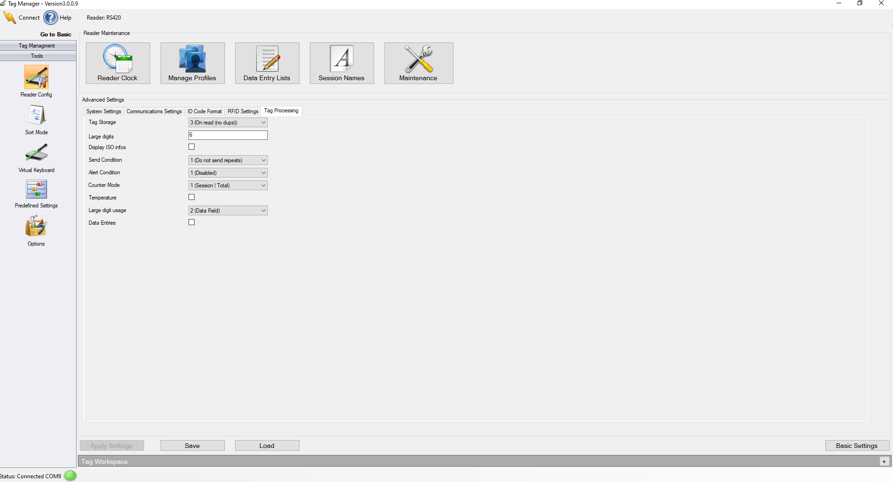

Or if you want the large digits to be the last 4 numbers of the Eid number, change the large digits to 4 and the large digit usage to 1(EID). There are of course many options you can set for what you see on the reader display

